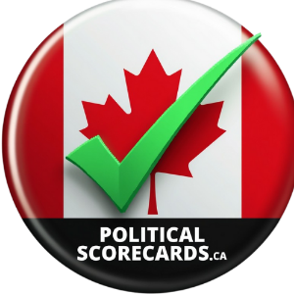Political Scorecards Canada

Principled Politics

Pledged Transparency

**Dear MPP Candidate**,

We know your busy so I'll be brief. **There is nothing more critical than informing voters in your riding of where you stand on Ontario's critical issues.**

**Please complete The MPP Questionnaire:**

<https://politicalscorecards.ca/ont-mpp-candidate-questionnaire-2025/>

This questionnaire will form a baseline for your Politicians Scorecard that will soon be seen across Ontario on <https://politicalscorecards.ca/>

**Note:** A lack of response will result in a score of zero on your future scorecard (15% awarded for questionnaire transparency), but most importantly the voters will not know where you stand when placing their vote.

Political Scorecards Canada will assist in putting your position in front of voters online, at townhalls, in social media and at events leading up to the election.

**Thank You for being proactive, transparent and accountable.**

Randy S. Murray

In gratitude and appreciation,

Political Scorecards Canada

<https://politicalscorecards.ca/contact-us/>